SMMS Band Program
2020-2021
Questions and Answers:
- Do I have to know how to play an instrument? Of course not! We will learn to play our instruments together.
- Is Band a financial obligation? Yes, but think of this as investing in your student’s education. Instruments require maintenance, mouthpieces, reeds, valve oil, and practice time. If you make a good investment and explain to your students that in the long run Band will have more value than just playing an instrument. Please know that finances should not discourage you from joining the program, we are here for success and opportunity.
- How do sixth grade students get an instrument? This year is different for safety reasons. The first two weeks we will learn about all the instruments and give the sixth graders an opportunity to see everything. We are going to use a selection system using physical characteristics, science, and algorithms and make the decision together.
- Should we rent or buy an instrument? My personal opinion is to rent first. If you would like to buy, I am happy to assist.
- What supplies to we need besides an instrument? Band fees will cover the classroom needs. It is a one-time fee of $40 for each student. This helps with uniformity of supplies and a guarantee of supplies needed.
- Will we need instruments on the first day of School? No, we will be learning the new adaptions for the school year.
- What instruments are played in Middle School Band? Flute, oboe, clarinet, bass clarinet, bassoon, alto saxophone, trumpet, French horn, trombone, baritone, tuba and percussion.
- With Covid-19 and changes in procedures how will we be able to participate in band? This year will look different, but please know that this class is doable and something you should try. Band in general is an independent class. Meaning, all students are expected to participate and do his/her part in practicing daily. Things will look different slightly, but you will still play and learn your instruments. If you want to learn and succeed it will be possible.

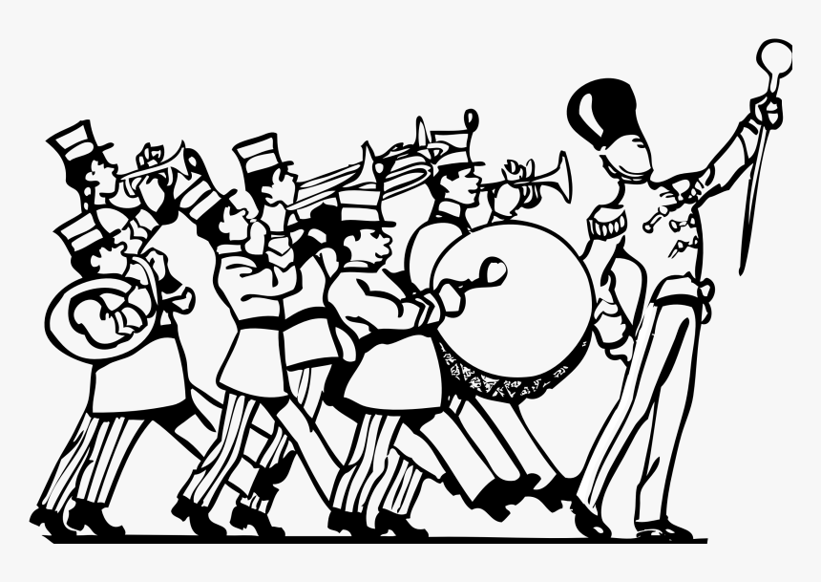
Fall 2020 Beginning of the Year
Calendar
August 3rd (Monday)-First day of school. Students do not need any materials for this class. We will be going over procedures and creating a seating chart.
August 6th and 7th (Thursday and Friday)-Digital learning days. Activities will be found on Canvas.
August 10th (Monday)- 7th and 8th graders bring instruments. School-owned instruments will be assigned.
August 10th-14th (Monday-Friday)- 6th grade parents will receive an email with a link to complete. This will help us all decide an instrument best for each student. Virtual meetings will be scheduled for parents/students/Ms. Crozier to conference and confirm.
***The calendar will be updated regularly. With this school year being abnormal please be kind and patient.***
Materials
Band Fees are $40 for all band students. This is a one-time payment and pays for classroom materials (binder, paper, music, highlighters, books, shirt). All fees can be paid on RevTrak, remember there is a small tax with anything purchased via RevTrak.
Anything Else?
Follow the Band on Facebook and Instagram!
Check out the band web page for Remind 101 codes, the calendar, and any other information.
